Use the class cheat sheet and materials for reference: <https://bitbucket.org/lmcohort2/materials/src/master/cheatsheet.md>

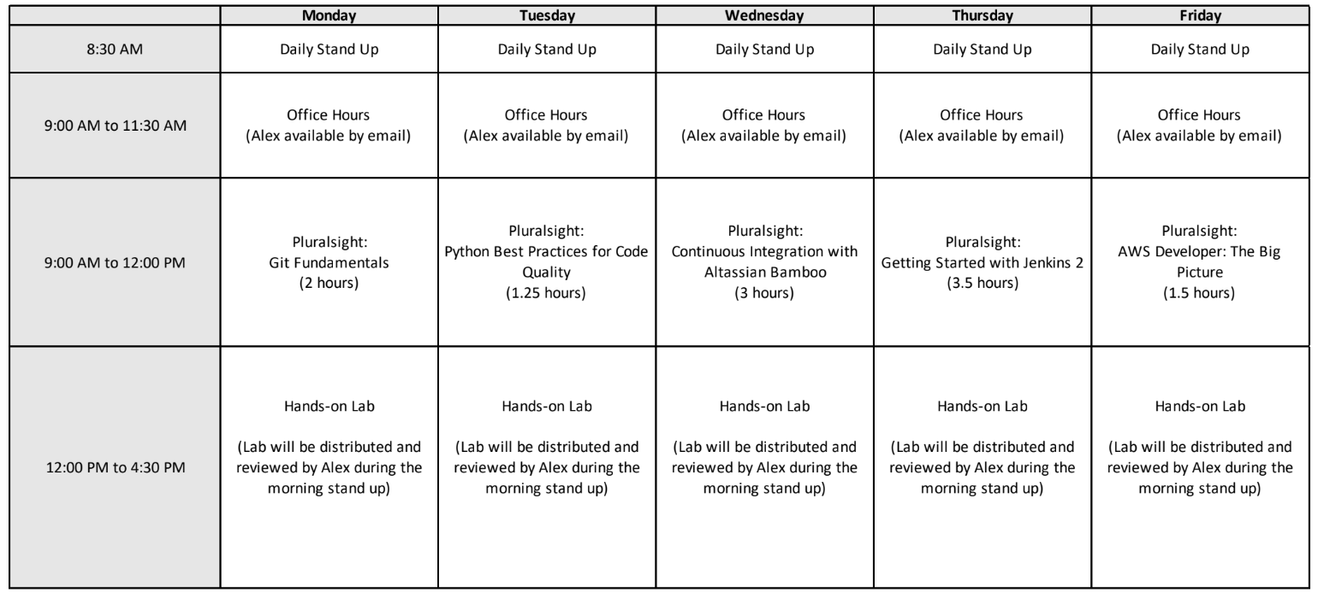

## Finish labs

### Weather app

Have all three methods implemented with unittests and no [flake8](http://flake8.pycqa.org/en/latest/) violations.

materials/REST_API/01_calling_apis_with_python.docx

materials/CI/01_lab_bamboo_weather_app_plan.docx

### Ansible

materials/Ansible/lab_04_deploying_a_webapp.docx

Optionally, do lab_05_ansible_awx.docx

### Git

Pro Git book (free online) <https://git-scm.com/book/en/v2>

Review exercises <https://www.katacoda.com/courses/git>

## Finish Reading The Phoenix Project